Names and NSIDs: Ruida Xie (rux793); Hao Li (hal356); Yinsheng Dong (yid164)

Project: jEdit

Change Number: [4]

Date: 04/02/2018

*Everything in italic should be changed as appropriate by you and should not be italic when submitted.*

(Add timestamps to log)

1. **Change Request*:***

Locate where the activity.log is and add timestamps to all kinds of messages. Currently there are no timestamps in the log file.

1. **Concept Location:**

The search started with locating activity.log file since it contains all logs the application created while running. I found it in Settings Directory under Utilities menu. A search for a log method was conducted, and the Log.java base class was discovered to contain relevant writing log methods. The source code in the same package was read, and _log() method was found. This method controls output log messages. This is a viable candidate to add features to.

**Table 1. The list of all the classes visited during concept location.**

|  |  |  |  |  |
| --- | --- | --- | --- | --- |
| **#** | **File name** | **Tool used** | **Located?** | **Comments** |
| 1 | Activity.log | Read File | Unchanged | Log messages stored here |
| 2 | Org.gjt.sp.util | Class search | Propagating | Utility classes stored here |
| 3 | Log.java | Read Source | Changed | Methods in this file related to logs. |
|  |  |  |  |  |
|  |  |  |  |  |

1. **Impact Analysis:**

**Table 2. The list of all the classes visited during impact analysis.**

|  |  |  |  |  |
| --- | --- | --- | --- | --- |
| **#** | **Class name** | **Tool used** | **Impacted?** | **Comments** |
| 1 | Log.java | Read Source, Find Usage | Changed | Import timestamp library and added current timestamp in _log() method |
|  |  |  |  |  |
|  |  |  |  |  |
|  |  |  |  |  |
|  |  |  |  |  |
|  |  |  |  |  |

1. **Learning process:** *Include a partial UML* ***class diagram.*** *The class diagram must contain all the classes that you visited and all the relations (dependencies) between the classes that you understood. (see Figure 1). Mark the classes that were changed with red text as in the example.*

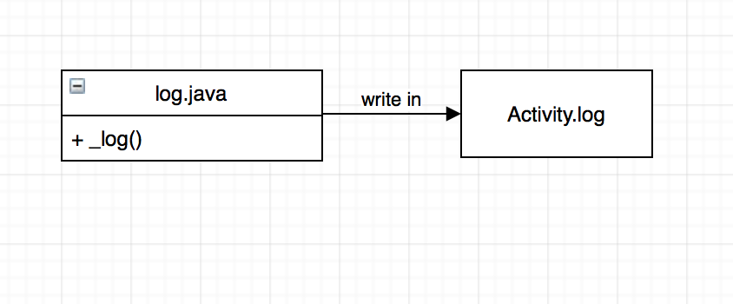

Figure 1 class diagram

1. **Description of the implementation:**

I changed _log() method in Log.java. Because this method controls what will be printed in the log file.

1. **Sources:** activity.log in settings directory*.*
2. **Highlighted Source Code:**

Log.java:

import java.sql.Timestamp

import java.text.SimpleDateFormat

private static final SimpleDateFormat sdf = new SimpleDateFormat(“yyyy.MM.dd.HH.mm.ss”)

private static void _log(int urgency, String source, String message)

{

Timestamp timestame = new Timestamp(System.currentTimeMillis());

String formatTimestamp = sdf.format(timestamp);

String fullMessage = “Timestamp: “ + formatTimestamp + “ “ + ‘[‘ + urgencyToString(urgency) + “] “ + source + “: “ + message;

….

}